**Benha University 4th Year (Sp. Geology) Students**

**Faculty of Science Mineral prospection and raw materials (435G)**

**Geology Department Date: 11 – 06 – 2017**

**Time Allowed: 2 hours**

**………………………………………………………………………………………………….............**

***Modal answer***

**1. Define only 6 items from the following: (12 marks)**

1. **Minable Reserve**

The minable reserve is very summarized accounting of the quantity and grade present within the stope boundary and finally sum total of all stopes. Minable reserve includes all three types of planned and unplanned dilution associated during large-scale mining.

1. **Pedogeochemical Survey**

“Pedo-geochemical survey” is also known as “soil survey”, which is widely used in geochemical exploration and often yields successful results as an anomalous enrichment of elements from underlying mineralization may occur due to secondary dispersion in the overlying soil, weathered product and groundwater during the process of weathering and leaching.

1. **Mineral exploration**

It is the process of finding ores (commercially viable concentrations of minerals) to mine, and is a much more intensive, organized and professional form of mineral prospecting.

1. **Geophysical exploration**

It is a method of exploration which uses the geophysical instruments in gathering geological data which is used in mineral exploration. Instruments are used in geophysical surveys to check for variations in gravity, magnetism, electromagnetism (resistivity of rocks) and a number of different other variables in a certain area.

1. **Primary dispersion**

It is the process of enrichment which occurred around primary halo of enrichment of element of commodity.

1. **Geochemical exploration**

Simplified meaning of Geochemical exploration is a method of finding an area anomalies in the commodity sought, or in elements known to be associated with the type of mineralization sought. Therefore, the primary role of geochemistry, here used to describe assaying or geological media, in mineral exploration.

1. **Average ore grade**

The average grade of an intersection along a trench, borehole, underground workings, cross- and long section, level plan, individual orebody, total deposit, national and global resources and reserves is computed by the formula:

(a) Composite grade of channel, borehole intersection:

Avereage Grade (g) = ∑ (L1 × g1 + L2 × g2 .... + Ln × gn) / ∑ (L1 + L2 …+ Ln )

where,

L = length of sample

g = grade of sample.

b) Average grade of section, plan, orebody, deposit, national and global:

Avereage Grade (g) = ∑ (t1 × g1 + t2 × g2 .... + tn × gn) / ∑ (t1 + t2 …+ tn )

where,

t = tonnes of subblock

g = grade of subblock.

1. **Atmogeochemical Survey**

“Vapor surveys” (atmo-geochemical) helps in the location of buried deposits through detection of halos of mercury, helium, nitrogen, sulfur dioxide, hydrogen sulfide, hydrocarbon, radon, methane and other gases and volatile elements, often at a considerable distance from the source of mineralization. Vapors can be detected from air and soils and in groundwater. Volatile elements are released through oxidation of ore deposits.

**2. Answer only two questions from the following: (12 marks)**

1. ***The Cutoff is the most significant relative economic factor for computation of resource* *and reserve from exploration data. (Discuss)***

“Cutoff” is the most significant relative economic factor for computation of resource and reserve from exploration data. It is an artificial boundary demarcating between low-grade mineralization and techno-economically viable ore that can be exploited at a profit. The cutoff boundaries change with the complexity of mineral distribution, method of mining, rate of production, metallurgical recovery, cost of production, royalty, taxes and finally the commodity price in international market.

Change of any one criterion or in combination of more gives rise to different cutoff and average grade of the deposit. Cutoff never changes on short-term basis.

Market trend is continuously monitored over long-term perspective and situation may compel to change the cutoff or close the mining operation. The concept works well in case of deposits with disseminated grade gradually changing from outer limits to core of the mineralization.

Cutoff grades are normally expressed in percentages (%) of metals for base, ferrous and nonferrous metals (Cu, Pb, Zn, Fe, Al, Cr etc.), and in grams per metric tonne (g/t) or parts per million (ppm) or ounces per dry short tonne for precious metals (Au, Ag, Pt, Pd etc.).

It can be given as a percentage equivalent (% Eq.) of the predominant mineral commodity in case of multi-metal deposits (% Eq. Cu means % equivalent of Cu).

% Eq. Cu = % Cu + { (Ni price × % Ni) / Cu price } + { (Au price × % Au) / Cu price } + …

% Eq. Zn = % Zn + { (Pb price × % Pb) / Zn price } + { (Ag price × % Ag) / Zn price } + …

1. ***Compare between Lithogeochemical Survey and Stream Sediments Survey as a*** ***geochemical Survey in mineral exploration.***

|  |  |
| --- | --- |
| Lithogeochemical Survey | Stream Sediments Survey |
| * Rock sampling is included in the techniques for follow-up because although it has been applied with some success in regional reconnaissance, it is really in detailed work, where there is good outcrop or where there is drill core, that this technique becomes most effective. * On a regional basis the most successful applications have been in the delineation of mineralized felsic plutons and of exhalative horizons. Plutons mineralized in copper and tungsten are usually enriched in these elements but invariably show high variability within a pluton. * It is important that the rock sampling is away from the weathering surficial processes which affected on the elemental distribution as well as the anomalies' locations. * In the hydrothermal deposits, there are usually leaching of the different precious element by the effect of the hydrothermal solution transferring them from the parent rocks to the country rocks leaving haloes surrounding the main mineralized ore bodies. * These haloes extended from cm to different kilometers, therefore main ore bodies are easily determining their location by determining the different haloes and their volume that divided into primary and secondary haloes. | * Stream sediment sampling is most widely used in all reconnaissance and detailed survey of drainage basins. * Many minerals, particularly the sulfide minerals, are unstable in weathering environment and will break down as a result of oxidation and other chemical reactions. * The process will motivate secondary dispersion of both ore and indicator elements. * The elements will move in solid and solution form to relative further distances within the drainage basin. * The mobility of the different elements will vary significantly and eventually detrital fine-grained particles of rocks, minerals, clay, solutions, organic and inorganic colloids enriched in ore and indicator elements will be deposited downstream. * The samples represent the best possible composite of weathered and primary rocks of the upstream catchments area. * It is comprised of unconsolidated material in a state of mechanical transportation by streams, springs and creeks. * The optimum size fraction varies in different environment and generally () 80-mesh size is recommended. * The samples are generally collected in dry season from natural sediment traps along stream courses below confluences or in three-point set around the confluence. * The choice of samples from first-, second- and third-order stream will depend on the terrain, climate and nature of weathering of the region. * Two sets of samples are collected at each location. The first set is panned for heavy mineral concentration and the second one is the wet-sieved () 200-mesh (75 micron) or () 80-mesh fraction of stream sediments. |

1. ***Write on the different stages of mineral explorations starting from geoscience stage to*** ***mine closure stage.***

**The Mineral Resource Development Cycle**

There are five stages in the mineral resource development cycle: Geoscience, Mineral Exploration, Mine Development, Mine Operation and Mine Closure.

**STAGE 1: GEOSCIENCE**

**What is geoscience?**

It’s a field of science that addresses the study of the earth. Although it deals with all issues relating to the Earth and its systems, one of its major uses is the development of our natural resources. Natural resources include minerals, metals, oil, gas, aggregates, soil, and water resources.

Geoscience often includes other areas of science such as biology, chemistry, physics as well as mathematics and engineering. A geologist, geochemist, geophysicist, environmental geologist and paleontologist are examples of geoscience career paths.

**STAGE 2: MINERAL EXPLORATION**

**What is mineral exploration?**

The first stage of the mineral resource development cycle is mineral exploration. Searching for ore bodies, or valuable minerals and metals that can be economically mined is the goal of exploration. The mineral exploration stage is a slow, yet very well-planned stage. It is rare to find an orebody with a high enough concentration of minerals or metals to develop a mine, but it all begins with mineral exploration. Good geological maps and reports created in the geoscience stage provide the road maps for explorationists.

Mineral Exploration is carried out by geologists, prospectors, junior exploration companies and/or mining companies. A geologist, geophysicist and prospector are examples of mineral exploration careers.

**STAGE 3: MINE DEVELOPMENT**

**What is mine development?**

The mine development stage only occurs if the mineral exploration stage is positive. There are three main goals during mine development:

1) Determine if the mineral deposit is worth mining (i.e. evaluate the mineral discovery)

2) Raise financing to develop the mine

**3) Plan to design and build a mine**

During the mine development stage, the company has to make many detailed plans and important decisions. It is a long, and intense, multi–phase process, sometimes taking up to 7 to 10 years to complete. Companies must follow a strict process as required by government laws. The project must be released from an environmental assessment (EA) before the company can receive the permits required to mine. These permits are called mining and surface leases. Companies must also have financial assurance to support mine closure. Various plans and reports are required, including for closure of the mine, geology and engineering studies, legal and financial work, and potential environmental and social impacts.

Accountants, construction workers, electricians, engineers, geologists, lawyers and workers specialized in various skilled trades are just a few of the types of careers needed.

**STAGE 4: MINE OPERATION**

**What is mine operation?**

The mine operation stage involves removing and processing mineral resources from the earth to make them useable. The mining method depends on many factors, including the size, shape and location of the valuable minerals. This concentration of valuable minerals is called an orebody. Mining methods include:

**1) Open–pit mining**

**2) Underground mining**

Open–pit mining is used for mineral deposits that are near the earth’s surface, while underground mining is used to extract ore that is buried deep! Once the ore has been removed or extracted, it is moved to a processing plant to separate the valuable minerals from the raw rock. The ore is sold and the leftover waste rock is safely stored.

Field and office work can occur near urban areas, but typically work occurs in remote areas. Corporate offices, consulting service offices and mine sites are some of the places you will find specialists working in this stage. A driller, electrician, environmental technologist, haulage truck driver, mine engineer, pipefitter, and warehouse worker are examples of careers in the mining stage.

**STAGE 5: MINE CLOSURE**

**What is mine closure?**

Mine closure is the last stage in the mineral development cycle. Mining is a temporary use of the land and all mines eventually close. Once mining is complete and the mine closes, the land must be left in a safe state that blends with the surrounding environment. This is called reclamation. Today’s mining processes ensure that safe and sound environmental management occurs at every stage of the mining cycle, and in particular, before mining begins.

Duties generally involve time shared doing field work, laboratory analysis and office work. Environmental technicians, environmental engineers, and specialists who study the soil, water, wildlife and vegetation are examples of career opportunities in the mine closure stage.

**3. Answer only two questions from the following: (12 marks)**

1. ***Compare between the “Old Style” and “Polygonal” methods as conventional*** ***resource/reserve estimation methods.***

|  |  |
| --- | --- |
| Old Style | Polygonal methods |
| The old-style method was in practice during past for single vein-type deposit like gold-bearing quartz veins of Kolar and Hutti, Karnataka, India, and gold mines in South Africa.  The auriferous veins are usually either exposed or close to the surface.  The geological and geochemical exploration is supported by few numbers of surface drill holes to establish the existence and continuity of mineralization down depth. The initial entry is by adit, incline and shaft.  The mine levels are developed within the orebody at short vertical interval of around 30 feet.  The extraction levels are suitably located on one side of the orebody based on dip of the lode.  The levels are connected by raises and winzes passing through the mineralization.  Channel and chip sampling is conducted at short interval of 3-6 feet all along the drives and raises.  The reserve= block area × thickness of vein × Sp. Gr.  The grade is computed by averaging all the sample values generated within the block. | Polygons are drawn either by joining each positive borehole or by perpendicular bisectrix around each borehole.  Reserve and grade can be estimated as square.  The horizontal area of each block is measured and multiplied by the thickness of the mineralization to get the volume.  The reserve = volume × bulk Sp. Gr. of ore.  The grade is computed by averaging the three corner values of the Polygon. |

1. ***The orientation survey is one of the key aspects of planning to evaluate which techniques are effective for the mineral exploration of a commodity sought. (Discuss)***

One of the key aspects of planning is to evaluate which techniques are effective for the commodity sought and in the area of search. This is known as an ***orientation survey.***

The best orientation survey is that in which a variety of sampling methods is tested over a prospect or deposit of similar geology to the target and in similar topographical conditions to determine the method which yields the best results.

A checklist for an orientation study is given below (Closs & Nichol 1989):

1. Clear understanding of target deposit type;
2. Understanding of surficial environment of the search area;
3. Nature of primary and secondary dispersion from the mineralisation;
4. Sample types available;
5. Sample collection procedures;
6. Sample size requirements;
7. Sample interval, orientation, and areal density;
8. Field observations required;
9. Sample preparation procedures;
10. Sample fraction for analysis;
11. Analytical method required;
12. Elemental suite to be analyzed;

Data format for interpretation.

1. ***In the mineral exploration, the area should have several characteristics while selection*** ***(Discuss).***

Area selection is a crucial step in professional mineral exploration.

This selection depends on:

It should be best,

most prospective,

Easy, possibility, cheaply and quickly finding the area in a mineral field, geological region or terrain.

Area selection is based on applying the theories behind ore genesis, the knowledge of known ore occurrences and the method of their formation, to known geological regions via the study of geological maps, to determine potential areas where the particular class of ore deposit being sought may exist.

Area selection is also influenced by the commodity (raw materials) being sought; exploring for gold occurs in a different manner and within different rocks and areas to exploration for oil or natural gas or iron ore. Areas which are prospective for gold may not be prospective for other metals and commodities.

Area selection may also be influenced by previous finds, a practice affectionately named subsurface control or nearology, and may also be determined in part by financial and taxation incentives and tariff systems of individual nations. The role of infrastructure may also be crucial in area selection, because the ore must be brought to market and infrastructure costs may render isolated ore uneconomic.

***4. Give brief on the conventional classification system of economic ore reserves and sub-economic resources. (12 marks)***

* The degree of assurance in the estimates of tonnage and grade can subjectively be classified by using convenient terminology.
* In order of increasing geological exploration creating high confidence level and techno-economic viability the categorization has broadly been grouped as “Economic reserves” and “Sub-economic conditional resources”.
* The economic ore reserves and sub-economic resources are further subdivided as ***Developed***, ***Proved***, ***Probable*** and ***Possible***.
* The classification system helps the investor in decision making for project formulation and activities required at different phases.
* These terms are supported by experience, time tested, and well accepted over years.
* The terminology is comparable with equivalent international nomenclature that is used by USGS or Russian systems as ***Measured***, ***Indicated*** and ***Inferred***.

***4.1.1. Developed***

* The exposed parts of orebody represent “Developed” or “Positive” or “Blocked” reserves.
* Exposure can be by trenches or trial pit on the surface for open-pit mines or bounded on all sides by levels above and below, and connected by raises and winzes on the sides of the block for underground mines.
* Definition or delineation drilling at 30-15 m interval completed and all sides are sampled.
* The risk of error in tonnage and grade is minimal.
* The confidence of estimate is ~90%.

***4.1.2. Proved***

* The “Proved” or “Measured” reserves are estimated based on samples from outcrops, trenches, development levels and diamond drilling.
* The drilling interval would be 200 or even 400 m for simple sedimentary bedded deposits (coal
* seam, iron ore) with expected continuity along strike, other than structural dislocation.
* The sample interval would be at 50 by 50 m for base metal deposits.
* The deposit is either exposed by trenches or trial pit for open-pit mines and by development of one or two levels for underground drilling.
* Further stope delineation drilling and sampling will continue to upgrade the category to developed reserves.
* The confidence of estimate is ~80%.

***4.1.3. Probable***

* The “Probable” or “Indicated” reserve estimate is essentially based on wide-spaced sampling, surface and underground drilling at 100-400 m interval depending on the complexity of the mineralization.
* The opening of the deposits by trial pit or underground levels is not compulsory to arrive at this category.
* The confidence of estimate is ~70%.
* *The sum total of Developed, Proved and Probable reserve is termed as “Demonstrated” category.*
* The reserve of a project under investment decision should contain about 60% in the Demonstrated category.

***4.1.4. Other Ore***

* Part of the ore reserve is blocked in Sill, Crown and Rib pillars for stability of the ground during mining operation and related impacts.
* This blocked reserve is designated as “Other Ore” and is monitored as Proved category.

***4.1.5. Possible***

* “Possible” or “Inferred” resources are based on few scattered sample information in the strike and dip extension of the mineral deposit.
* There would be sufficient evidences of mineralized environment within broad geological framework having confidence of about 50%.
* The possible resource will act as sustainable replacement of mined out ore.

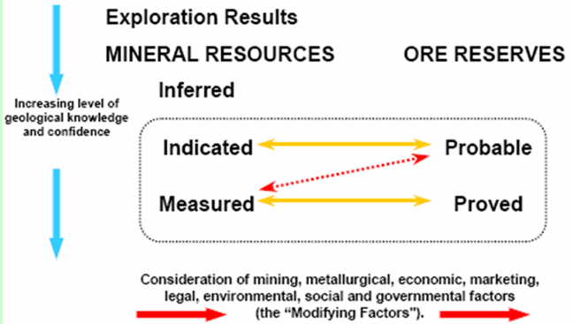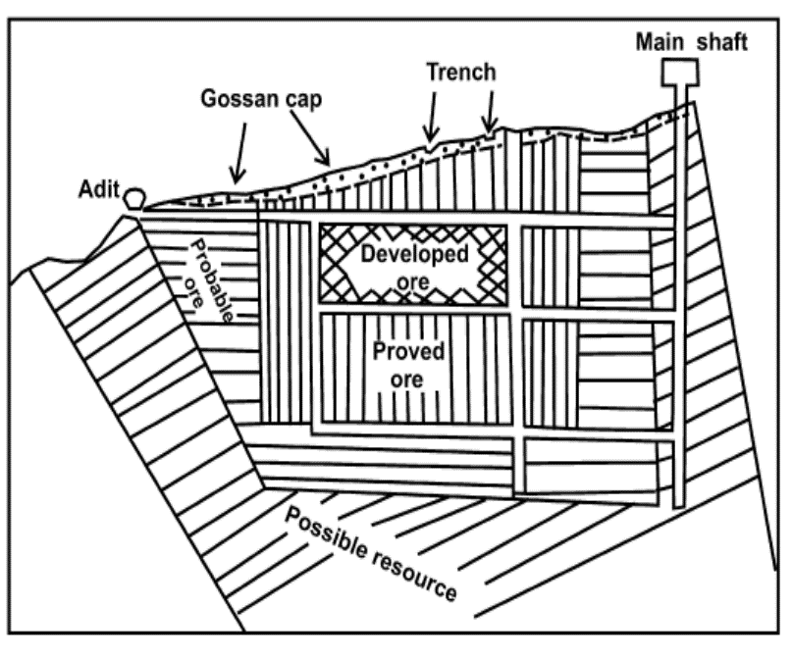

***With my best wishes***

***Dr. Amr Abdelnasser***